Activity | Data Type
Number of beatings from Wife | Discrete
Results of rolling a dice | Discrete
Weight of a person | Continous
Weight of Gold | Continous
Distance between two places | Continous
Length of a leaf | Continous
Dog's weight | Continous
Blue Color | Discrete
Number of kids | Discrete
Number of tickets in Indian railways | Discrete
Number of times married | Discrete
Gender (Male or Female) | Discrete
Q1) Identify the Data type for the Following:

Q2) Identify the Data types, which were among the following
Nominal, Ordinal, Interval, Ratio.
Data | Data Type
Gender | Nominal
High School Class Ranking | Ordinal
Celsius Temperature | Interval
Weight | Ratio
Hair Color | Nominal
Socioeconomic Status | Interval
Fahrenheit Temperature | Interval
Height | Ratio
Type of living accommodation | Ordinal
Level of Agreement | Interval
IQ(Intelligence Scale) | Interval
Sales Figures | Interval
Blood Group | Nominal
Time Of Day | Interval
Time on a Clock with Hands | Interval
Number of Children | Interval
Religious Preference | Nominal
Barometer Pressure | Interval
SAT Scores | Interval
Years of Education | Nominal

Q3) Three Coins are tossed, find the probability that two heads and one tail are obtained?
Solution: Coin tosses three times
Possible outcomes=
(H,H,H),(H,T,H),(H,H,T),(T,T,H),(T,H,H),(T,H,T),(T,T,H),(T,T,T)
Here, the condition is 2H&1T=(H,T,H),(H,H,T),(T,H,H)
=3/8

Q4) Two Dice are rolled, find the probability that sum is
- Equal to 1
- Less than or equal to 4
- Sum is divisible by 2 and 3
Solution: 2 Dice are rolled
Possible outcomes=(1,1) (1,2) (1,3) (1,4) (1,5) (1,6)
(2,1) (2,2) (2,3) (2,4) (2,5) (2,6)
(3,1) (3,2) (3,3) (3,4) (3,5) (3,6)
(4,1) (4,2) (4,3) (4,4) (4,5) (4,6)
(5,1) (5,2) (5,3) (5,4) (5,5) (5,6)
(6,1) (6,2) (6,3) (6,4) (6,5) (6,6)
Then,So n(S)=36
- Condition 1:There "Nothing" that we get sum equal 1
- Condition 2:
Equal to 4:(1,3) (2,1) (2,2) (3,1)=1/6
- Condition 3:Sum is divisible by 2&3:(1,5) (2,4) (3,3) (4,2) (5,1)=1/6

Q5) A bag contains 2 red, 3 green and 2 blue balls. Two balls are drawn at random. What is the probability that none of the balls drawn is blue?

Solution:Total balls n(S)=2 red+3 green+2 blue=7 balls
=5/7

Q6) Calculate the Expected number of candies for a randomly selected child
Below are the probabilities of count of candies for children (ignoring the nature of the child-Generalized view)
CHILD | Candies count | Probability
A | 1 | 0.015
B | 4 | 0.20
C | 3 | 0.65
D | 5 | 0.005
E | 6 | 0.01
F | 2 | 0.120
Child A – probability of having 1 candy = 0.015.
Child B – probability of having 4 candies = 0.20
Solution:1*0.015+4*0.20+3*0.65+5*0.005+6*0.01+2*0.120
=3.09

Q7) Calculate Mean, Median, Mode, Variance, Standard Deviation, Range & comment about the values / draw inferences, for the given dataset
- For Points,Score,Weigh>
Find Mean, Median, Mode, Variance, Standard Deviation, and Range and also Comment about the values/ Draw some inferences.
Use Q7.csv file
Solution:Mean 3.596563 3.21725 17.84875
Median 3.695 3.325 17.71
Mode 3.92 3.44 17.02
Variance 0.285881 0.957379 3.193166
Standard 0.534679 0.978457 1.786943
Range 2.17 3.911 8.4
Points and weigh have 2 modes each.
Q8) Calculate Expected Value for the problem below
- The weights (X) of patients at a clinic (in pounds), are
108, 110, 123, 134, 135, 145, 167, 187, 199
Assume one of the patients is chosen at random. What is the Expected Value of the Weight of that patient?
Solution:Expected Value of the weight of the patient=145.33

Q9) Calculate Skewness, Kurtosis & draw inferences on the following data
Cars speed and distance
Use Q9_a.csv
Solution: Mean 14.5 42.98
Varaince 27.95918 664.0608
Standard Deviation 5.287644 25.76938
Skewness -0.11751 0.806895
Kurtosis -0.50899 0.405053
Inferences:
1.For Speed,
a.Negitive skewness-long tail on left hand side.
b.Negitive kurtosis-Peak of data points is shorter than of ND.
2.For Distance
a.Positive skewness -long tail on right side.
b.Positive kurtosis-Peak of data points is taller than of ND.

SP and Weight(WT)
Use Q9_b.csv
Mean 121.5403 32.41258
Variance 201.113 56.14225
STD 14.18143 7.492813
Skew 1.61145 -0.61475
Kurtosis 2.977329 0.950291

Q10) Draw inferences about the following boxplot & histogram

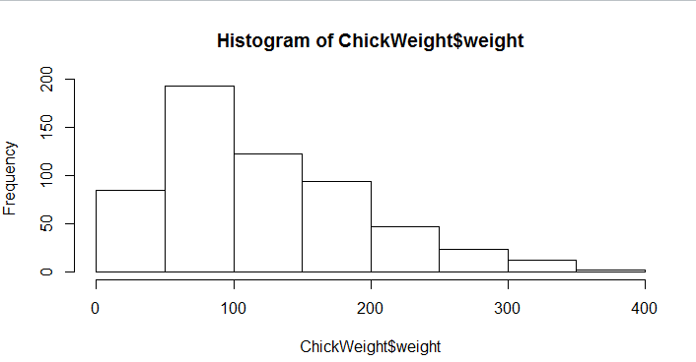

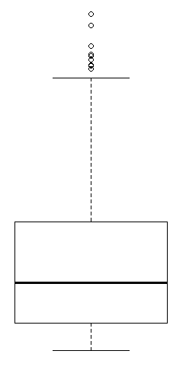
Solution:
Inference:
1.according to histogram most of data points (around 80%) are located 0-200.
2.Histogram shows the probability distribution is right skewed or positive skewness observed.
3.Median can be less then mean.
Inference:F
Q11) Suppose we want to estimate the average weight of an adult male in Mexico. We draw a random sample of 2,000 men from a population of 3,000,000 men and weigh them. We find that the average person in our sample weighs 200 pounds, and the standard deviation of the sample is 30 pounds. Calculate 94%,98%,96% confidence interval?
Solution:94% Confidence Interval [198.74,201.26]
96% Confidence Interval [198.61,201.39]
98% Confidence Interval [198.42,201.58]
Q12) Below are the scores obtained by a student in tests
34,36,36,38,38,39,39,40,40,41,41,41,41,42,42,45,49,56
- Find mean, median, variance, standard deviation.
- What can we say about the student marks?
Solution: Mean 41
Meadian 40.5
Variance 25.52941
Stan 5.052664

Q13) What is the nature of skewness when mean, median of data are equal?
Solution:Normal distribution,skewness is zero
Q14) What is the nature of skewness when mean > median ?
Solution:Distribution is positively skewed
Q15) What is the nature of skewness when median > mean?
Solution:Distribution is negatively skewed
Q16) What does positive kurtosis value indicates for a data ?
Solution:Sharp curve-Leptokurtik
Q17) What does negative kurtosis value indicates for a data?
Solution:Flat Curve-Platykurtik
Q18) Answer the below questions using the below boxplot visualization.
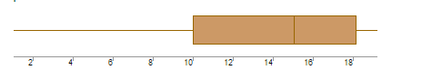
What can we say about the distribution of the data?
What is nature of skewness of the data?
What will be the IQR of the data (approximately)?
Solution:75% Data points are more than 10
Left Skewness
IQR=18-10
=8

Q19) Comment on the below Boxplot visualizations?
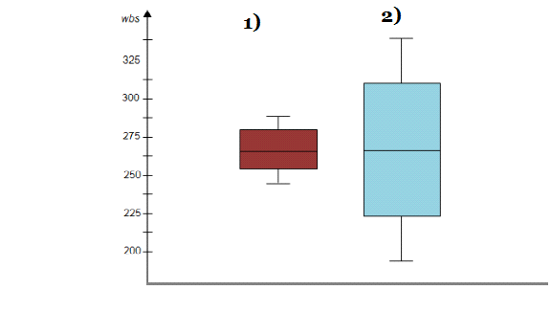
Draw an Inference from the distribution of data for Boxplot 1 with respect Boxplot 2.
Solution:Following illustrations can be made
- Range data points of box plot 2 is more than that of box plot 1.
- IQR(1) is less than IQR(2)
- Median values of both the data are equal.
Q 20) Calculate probability from the given dataset for the below cases

Data _set: Cars.csv
Calculate the probability of MPG of Cars for the below cases.
MPG <- Cars$MPG
- P(MPG>38)
- P(MPG<40)
c. P (20<MPG<50)
Solution:P(MPG>38)=33/81
P(MPG<40)=61/81
P(20<MPG<50)=69/81

Q 21) Check whether the data follows normal distribution
- Check whether the MPG of Cars follows Normal Distribution
Dataset: Cars.csv

- Check Whether the Adipose Tissue (AT) and Waist Circumference(Waist) from wc-at data set follows Normal Distribution
Dataset: wc-at.csv
Solution:At and Waist doesn't follow normal distribution because Mean,Mode and Median are different

Q 22) Calculate the Z scores of 90% confidence interval,94% confidence interval, 60% confidence interval
Solution:60%=0.842
90%=1.645
94%=1.88
Q 23) Calculate the t scores of 95% confidence interval, 96% confidence interval, 99% confidence interval for sample size of 25
Solution:95%=2.064
96%=2.172
97%=2.797
Q 24) A Government company claims that an average light bulb lasts 270 days. A researcher randomly selects 18 bulbs for testing. The sampled bulbs last an average of 260 days, with a standard deviation of 90 days. If the CEO's claim were true, what is the probability that 18 randomly selected bulbs would have an average life of no more than 260 days
Hint:
rcode pt(tscore,df)
df degrees of freedom
t - statistics for the data is given as follows:
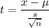
x = mean of the sample of bulbs = 260
μ = population mean = 270
s = standard deviation of the sample = 90
n = number of items in the sample = 18
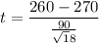
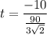
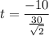
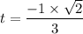
t = - 0.471
For probability calculations, the number of degrees of freedom is n - 1, so here you need the t-distribution with 17 degrees of freedom.
The probability that t < - 0.471 with 17 degrees of freedom assuming the population mean is true, the t-value is less than the t-value obtained With 17 degrees of freedom and a t score of - 0.471, the probability of the bulbs lasting less than 260 days on average of 0.3218 assuming the mean life of the bulbs is 300 days.
v

